Tab 1

Coin test (Data obtained from ADC)

**10 cm distance 10 cm height**

**Drop 1:**

Mean: 614.788

Median: 521.0

Standard Deviation: 376.55705418435593

Min: 140

Max: 1152

Number of Zeros: 0

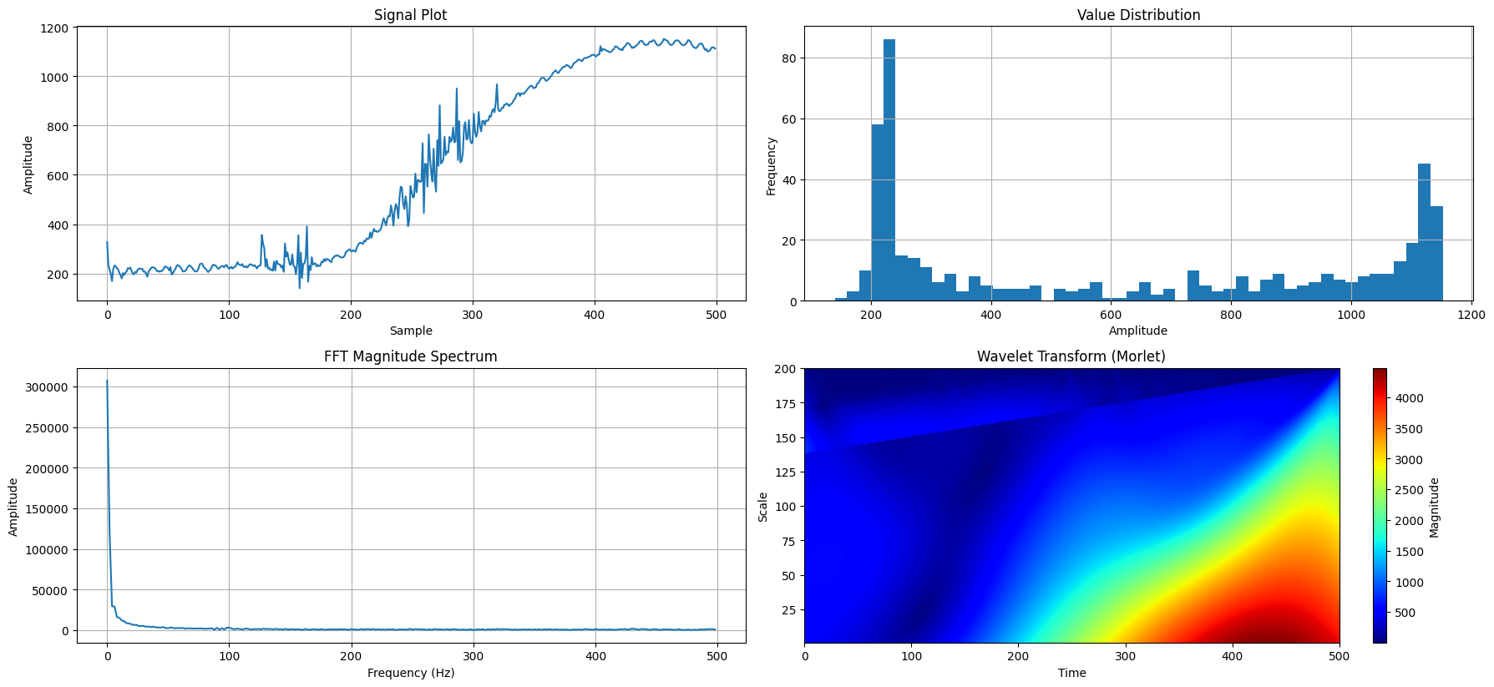Drop 2:

Mean: 448.904

Median: 0.0

Standard Deviation: 744.4052382835575

Min: 0

Max: 4000

Number of Zeros: 270

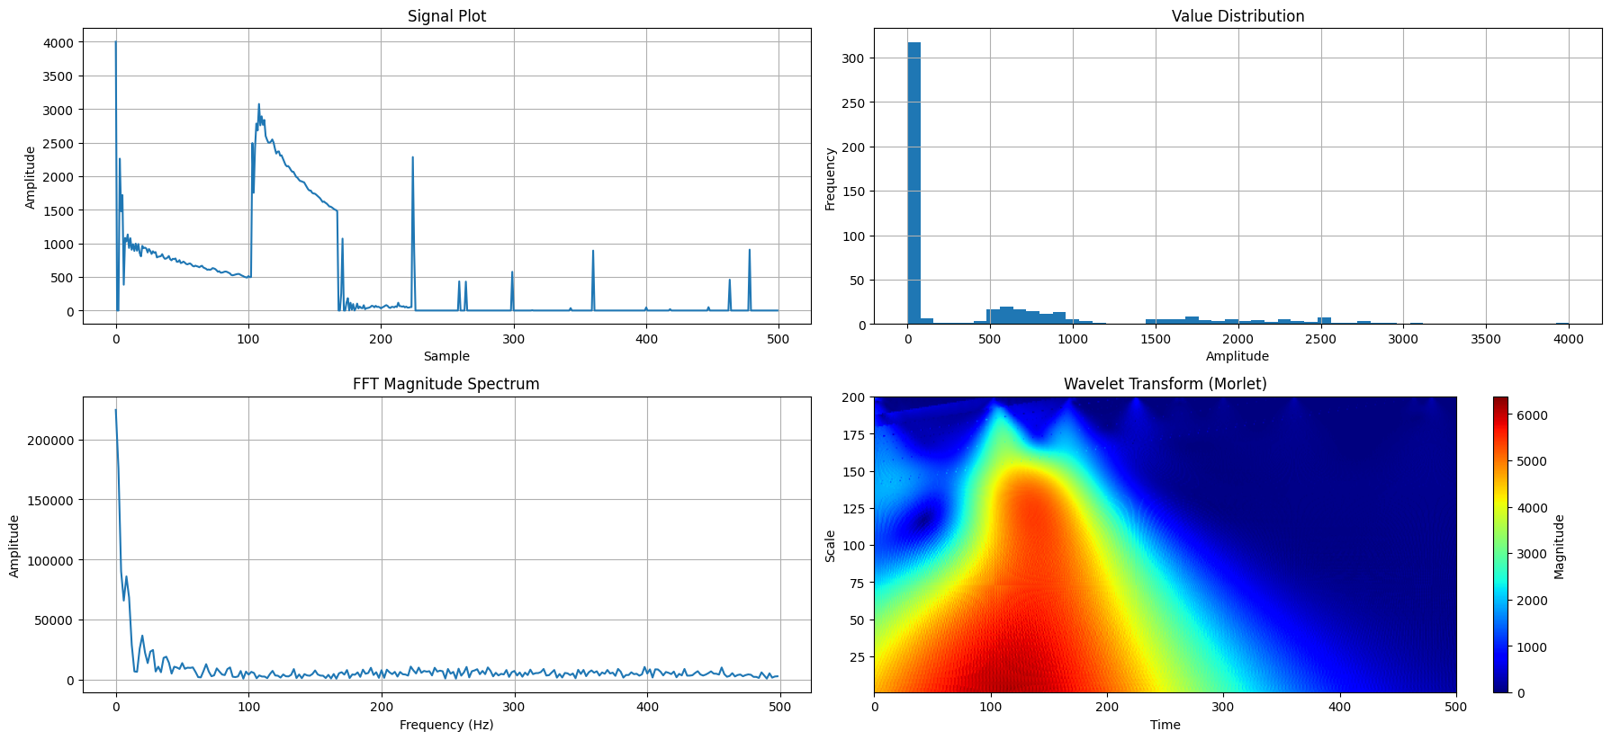

Mean: 249.344

Median: 0.0

Standard Deviation: 559.8418005686963

Min: 0

Max: 3998

Number of Zeros: 380

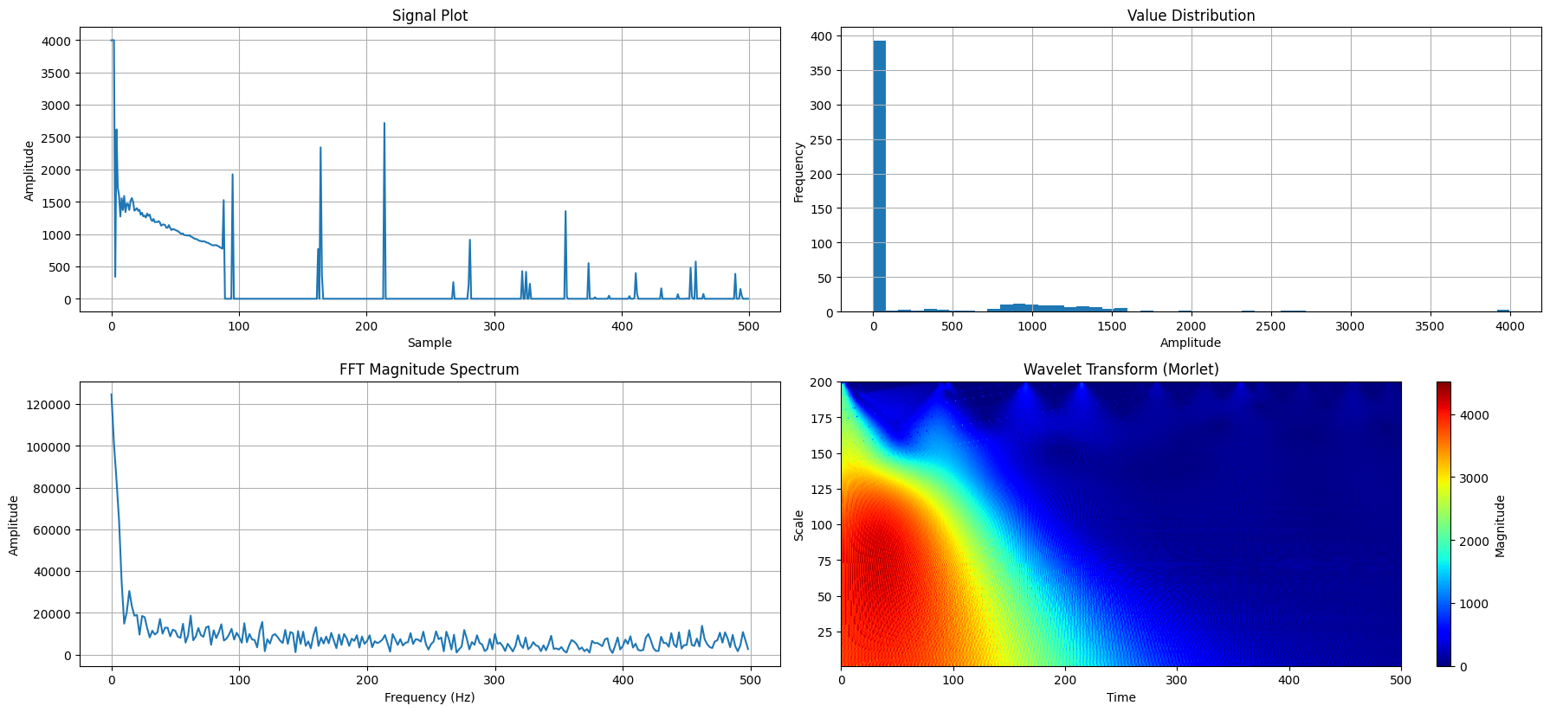

**10 cm distance 30 cm height**

**Mean: 160.126**

**Median: 0.0**

**Standard Deviation: 364.1374879410248**

**Min: 0**

**Max: 3995**

**Number of Zeros: 310**

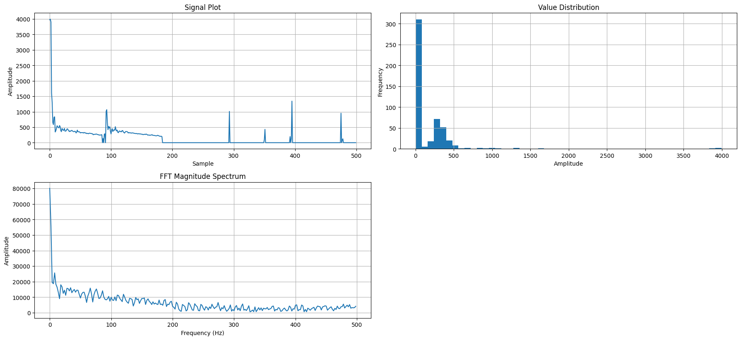

**Mean: 309.744**

**Median: 0.0**

**Standard Deviation: 621.1682883599259**

**Min: 0**

**Max: 3998**

**Number of Zeros: 376**

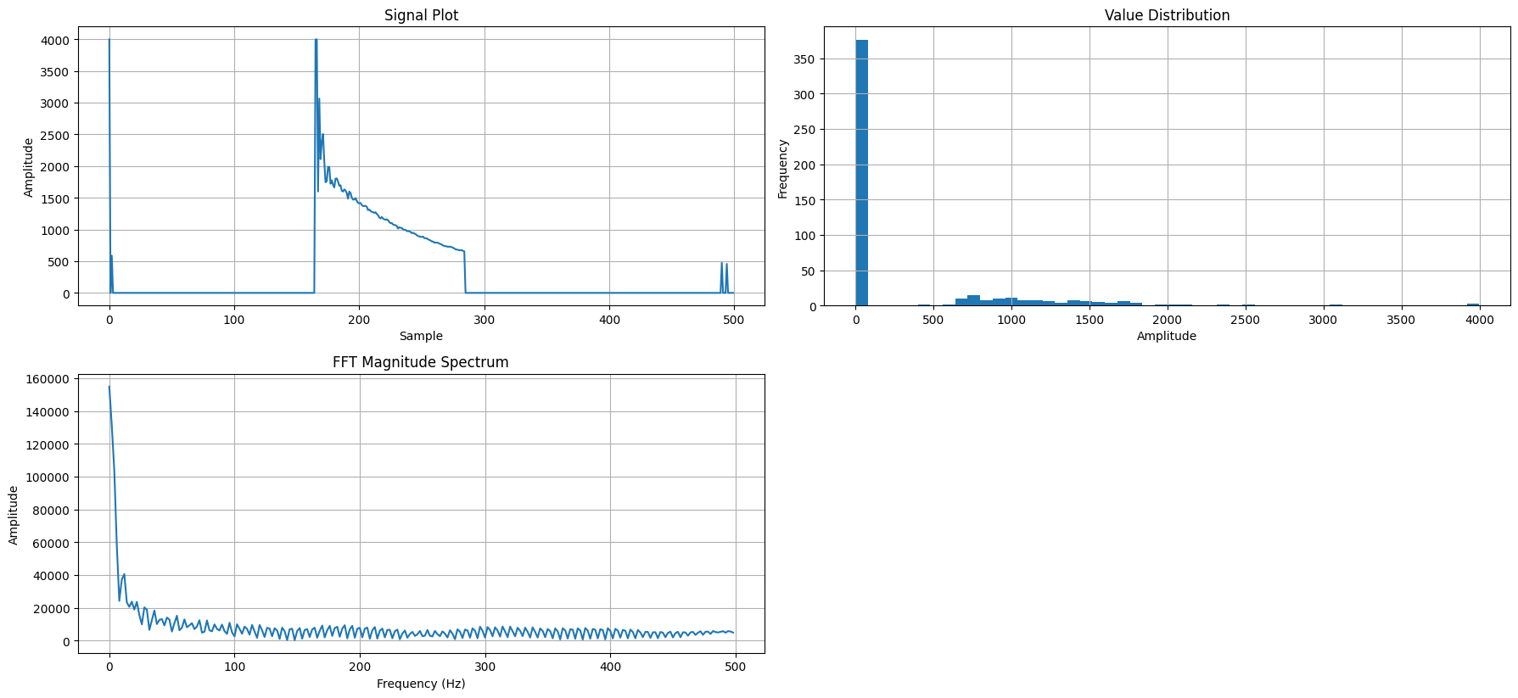

**Mean: 246.782**

**Median: 263.0**

**Standard Deviation: 77.26822423221593**

**Min: 0**

**Max: 348**

**Number of Zeros: 1**

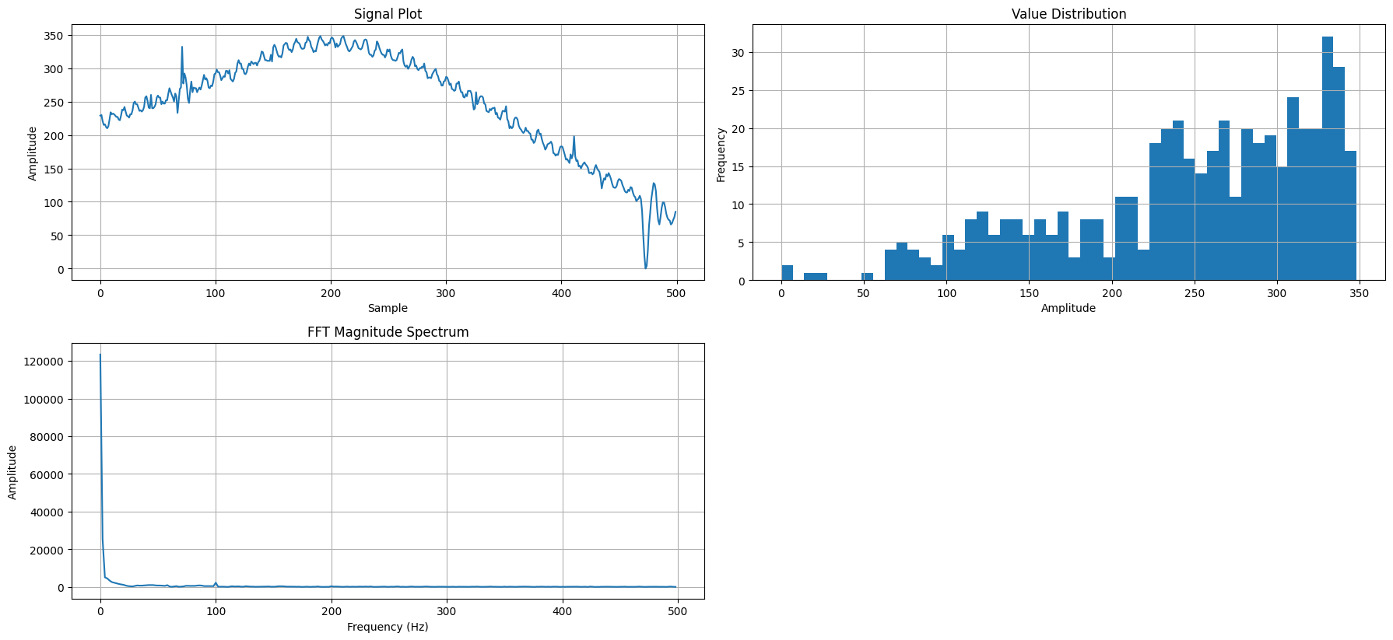

**20cm:**

**Drop 1:**

**Mean: 20.638**

**Median: 0.0**

**Standard Deviation: 188.29068738522363**

**Min: 0**

**Max: 3938**

**Number of Zeros: 452**

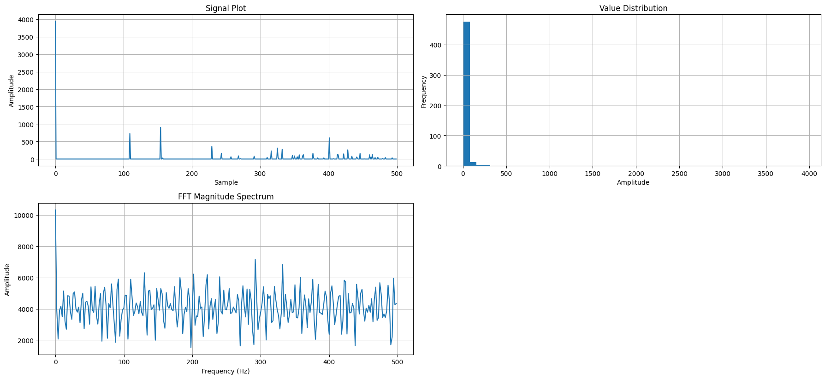

**Mean: 22.62**

**Median: 0.0**

**Standard Deviation: 243.44662577246785**

**Min: 0**

**Max: 3996**

**Number of Zeros: 469**

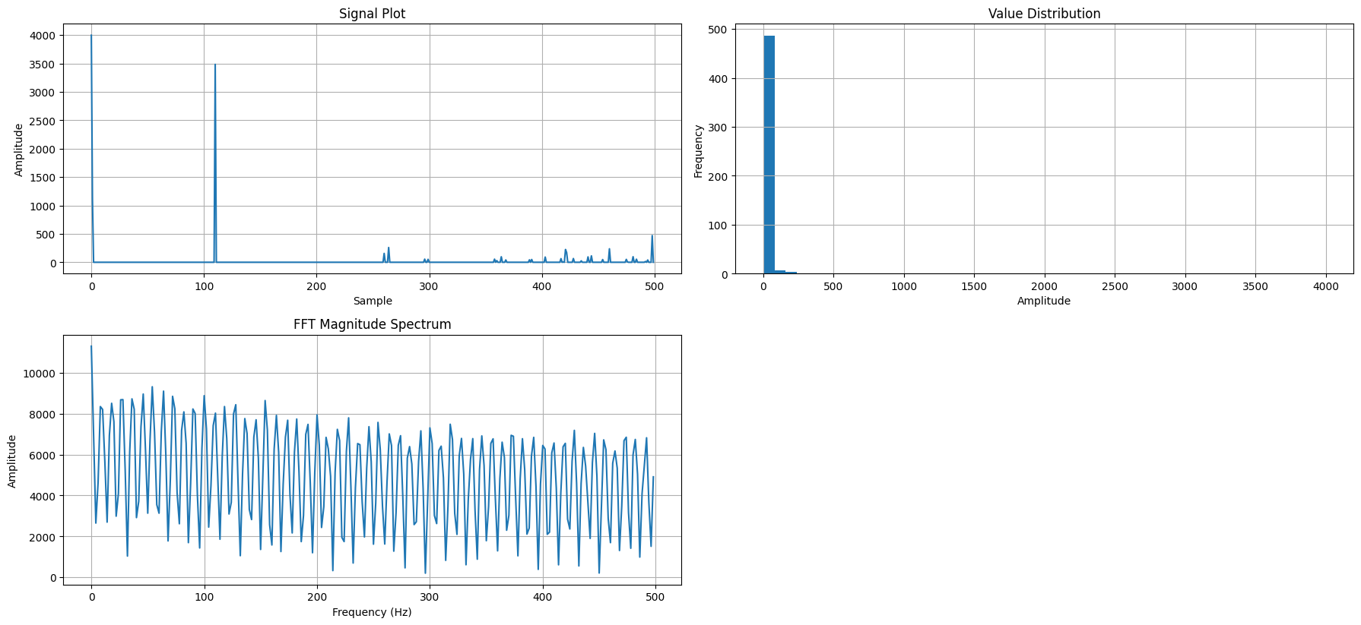

**Mean: 20.41**

**Median: 0.0**

**Standard Deviation: 230.14777404963098**

**Min: 0**

**Max: 4000**

**Number of Zeros: 482**

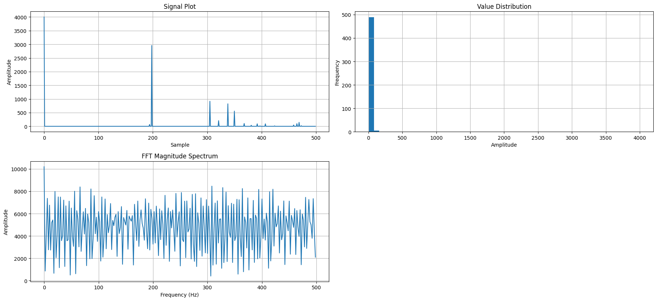

**30cm**

**Mean: 108.322**

**Median: 59.5**

**Standard Deviation: 231.18041940441233**

**Min: 0**

**Max: 3998**

**Number of Zeros: 107**

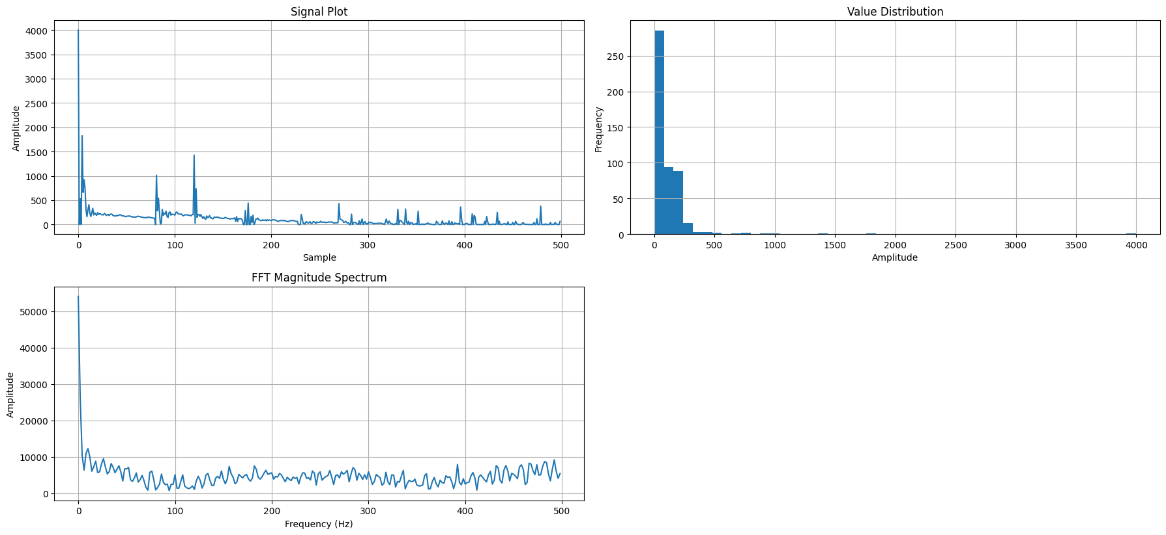

Compiled results with constant wave

H10 D10 Coin

Drop 1:

FFT Max Amplitude: 0.360389

FFT Gradient: -0.00020605767903103794

Average Time Between Peaks (ms): 1.82962962962963

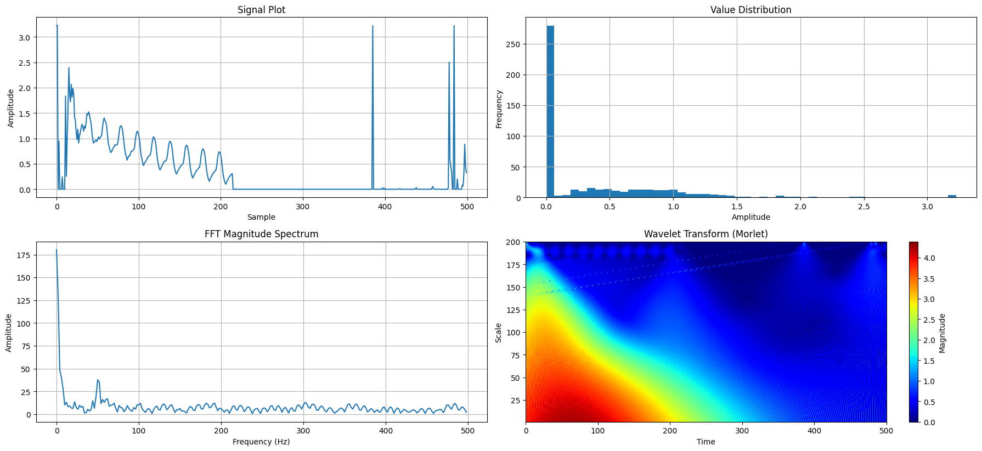

Drop 2:

FFT Max Amplitude: 0.5082906

FFT Gradient: -0.0009914643081037698

Average Time Between Peaks (ms): 1.9695652173913043

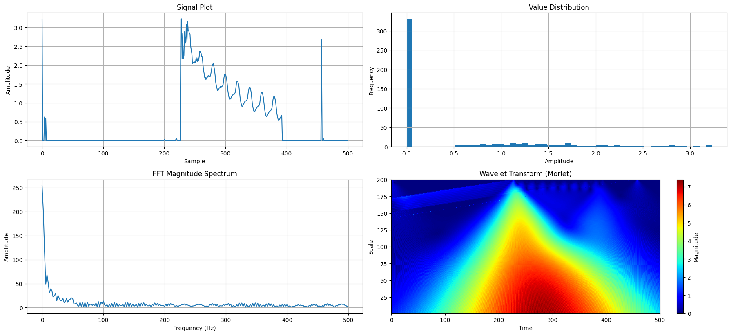

Drop 4:

FFT Max Amplitude: 1.1292246

FFT Gradient: -0.0023704175982787517

Average Time Between Peaks (ms): 0.7099999999999999

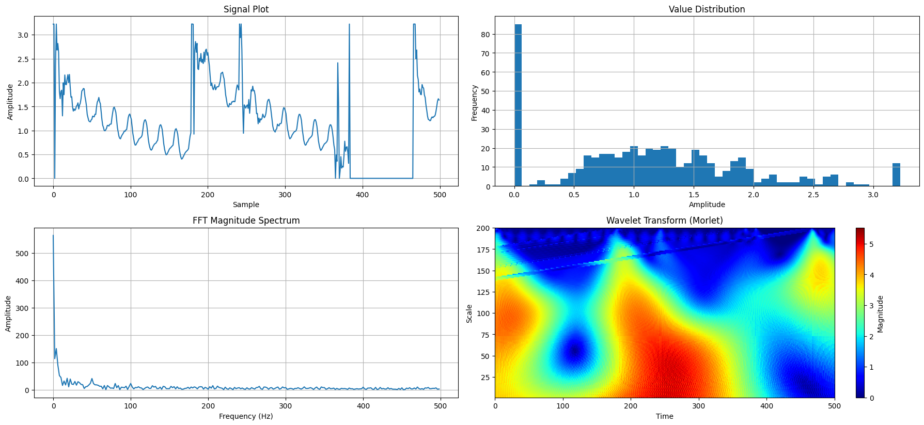

Drop 5:

FFT Max Amplitude: 0.4330444

FFT Gradient: -0.0007175402133189099

Average Time Between Peaks (ms): 1.1828571428571428

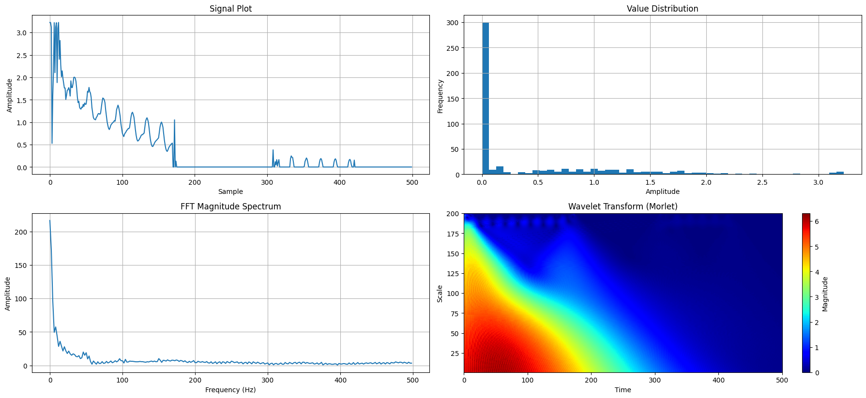

Drop 10:

FFT Max Amplitude: 0.11947699999999999

FFT Gradient: -0.00020940046875022895

Average Time Between Peaks (ms): 2.7555555555555555

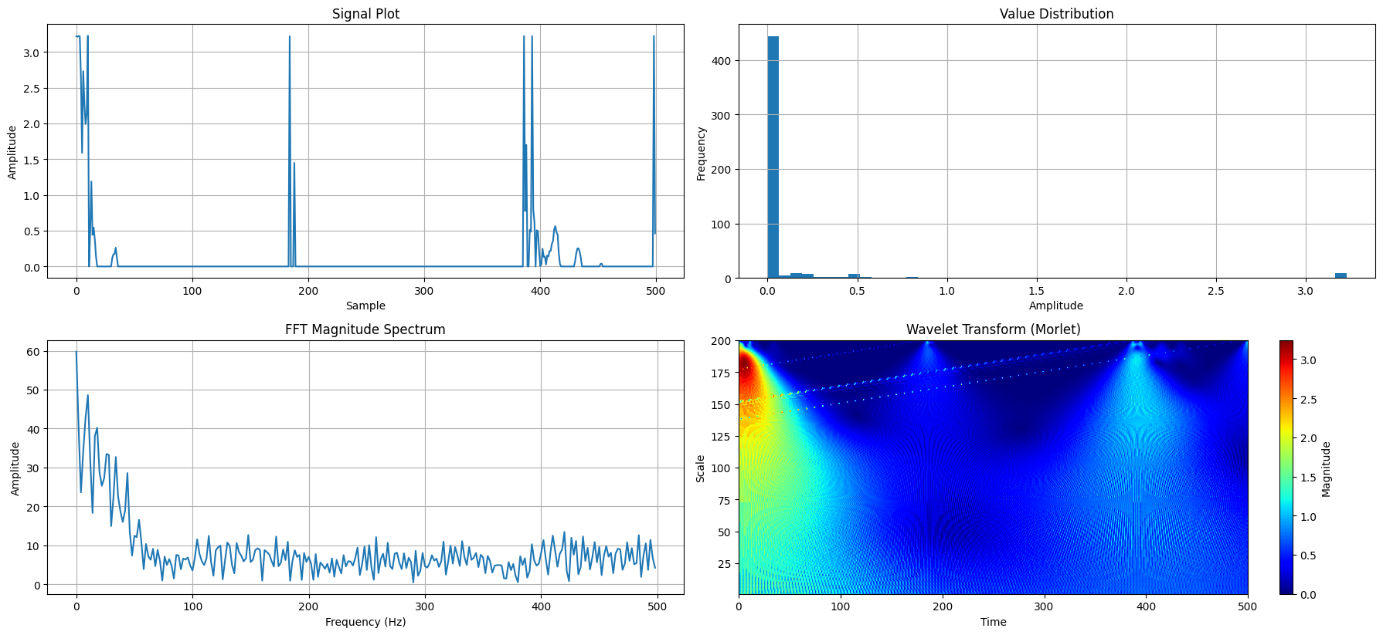

Drop 15:

FFT Max Amplitude: 0.13170179999999998

FFT Gradient: 0.00016125363933048028

Average Time Between Peaks (ms): 0.846551724137931

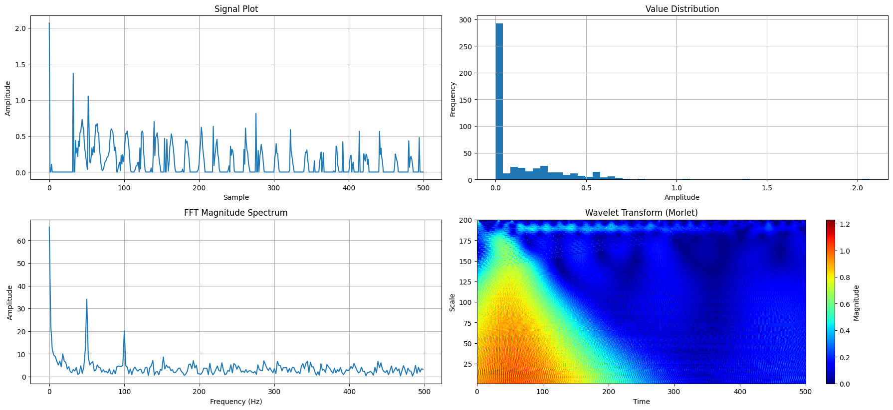

Drop 20:

FFT Max Amplitude: 0.36890860000000003

FFT Gradient: -0.0014536408045280294

Average Time Between Peaks (ms): 1.0081632653061225

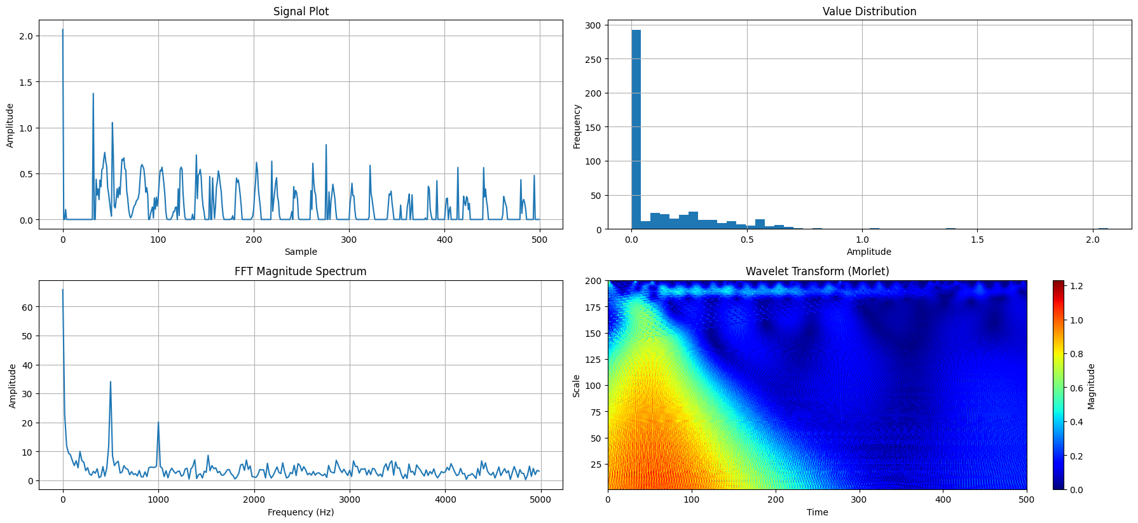

Drop 22:

FFT Max Amplitude: 0.36890860000000003

FFT Gradient: -0.0014536408045280294

Average Time Between Peaks (ms): 1.0081632653061225

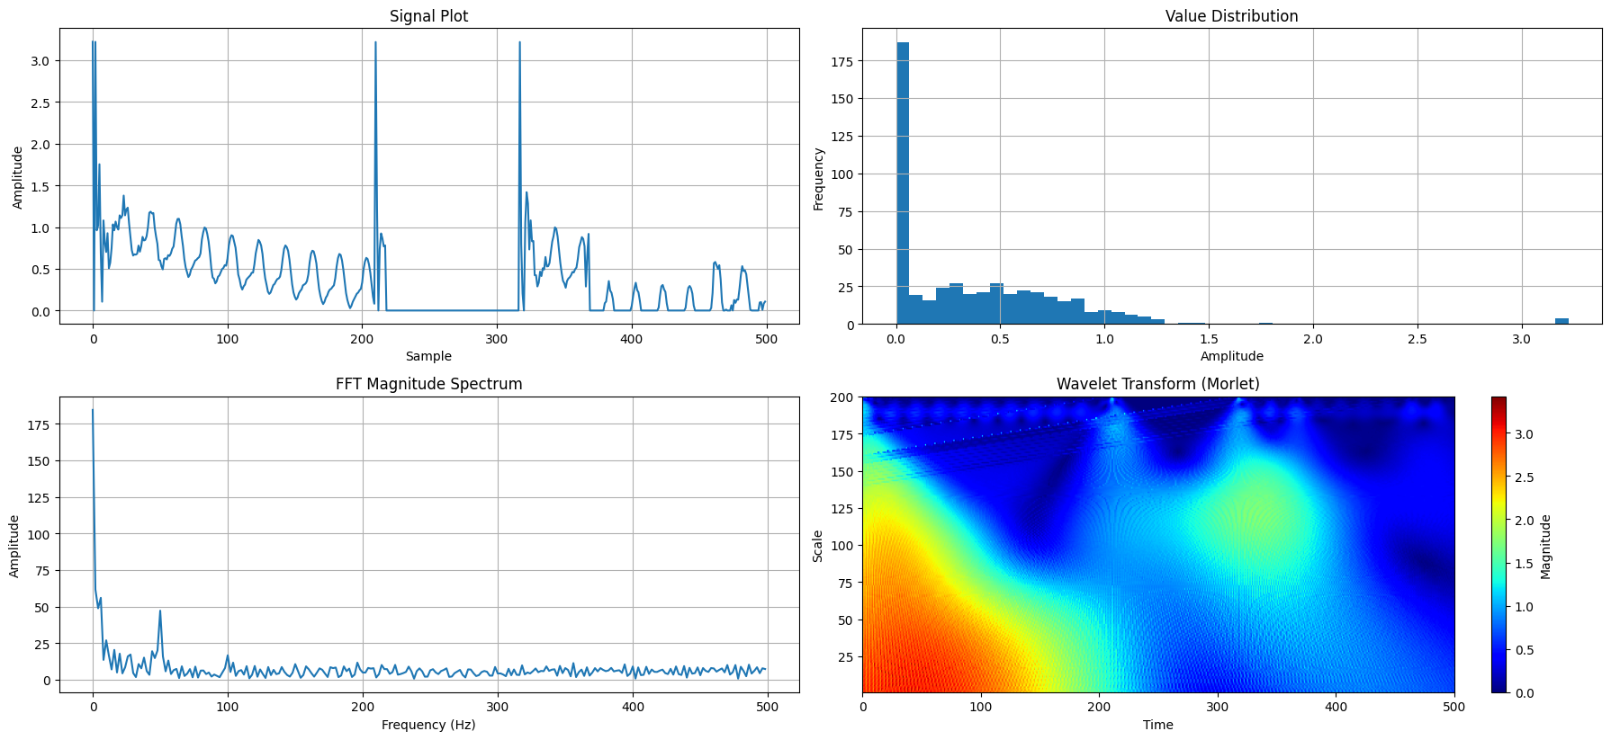

Drop 25:

FFT Max Amplitude: 0.232321

FFT Gradient: -0.00021979381668304487

Average Time Between Peaks (ms): 1.3735294117647059

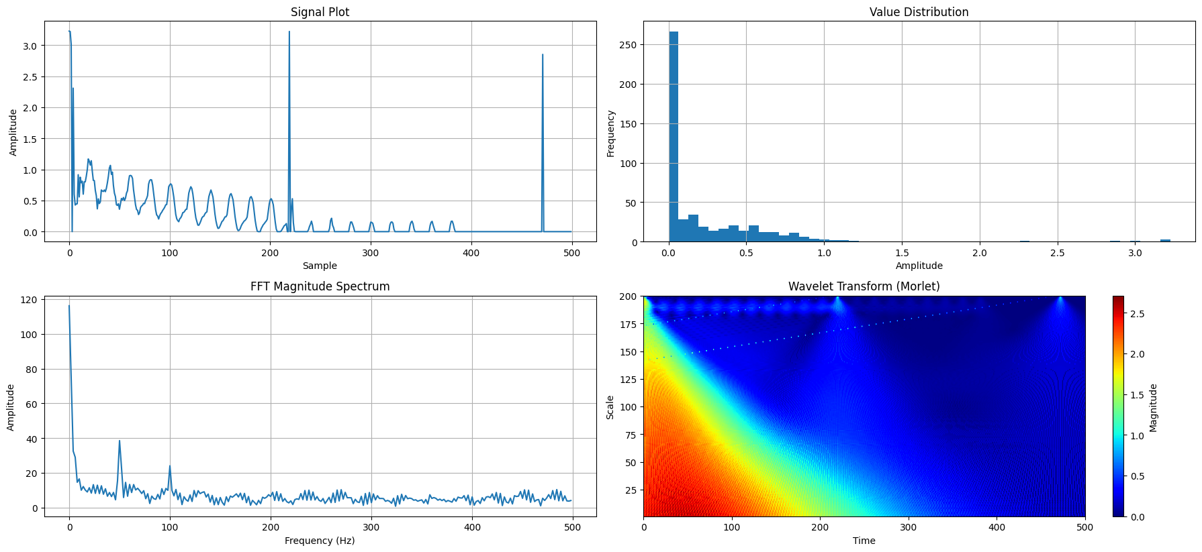

Drop 28:

FFT Max Amplitude: 0.3447288

FFT Gradient: -0.00042982890676763065

Average Time Between Peaks (ms): 1.2615384615384617

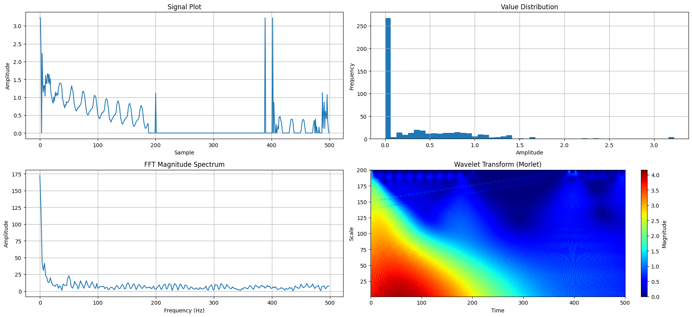

Drop 30:

FFT Max Amplitude: 0.5245614

FFT Gradient: -0.0010956253947155615

Average Time Between Peaks (ms): 0.8500000000000001

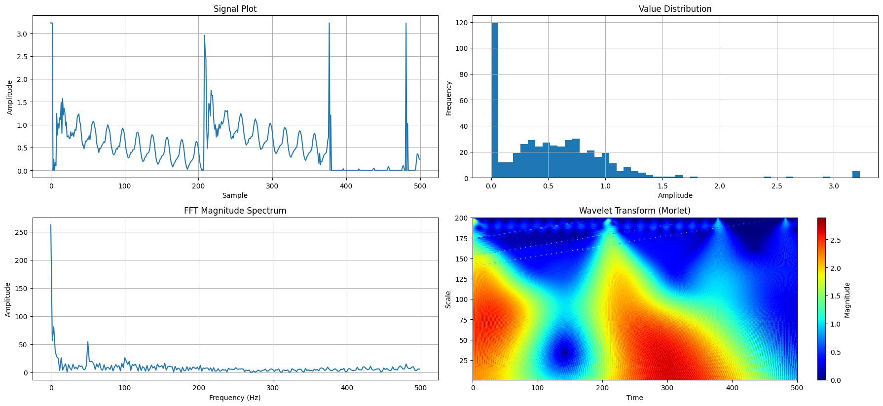

Eraser H10 D10

Drop 1:

FFT Max Amplitude: 0.069162

FFT Gradient: -6.709570911233651e-07

Average Time Between Peaks (ms): 2.0

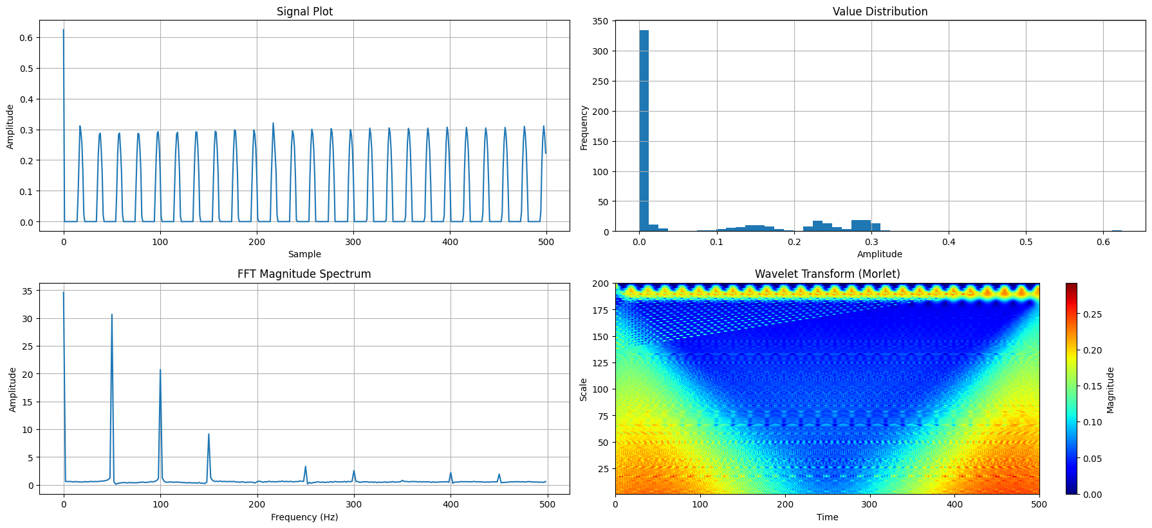

Drop 2:

FFT Max Amplitude: 0.0742376

FFT Gradient: -4.43452832365789e-07

Average Time Between Peaks (ms): 1.932

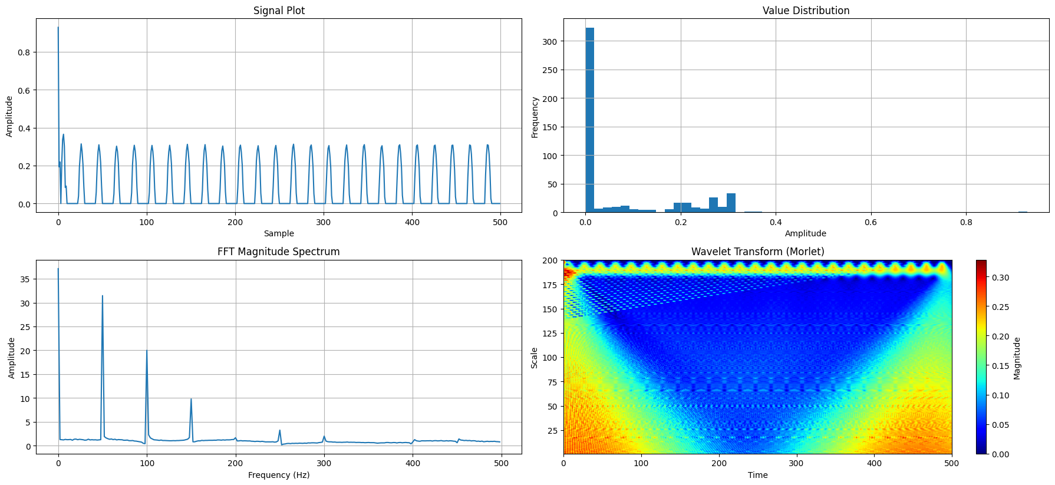

Drop 3:

FFT Max Amplitude: 0.0676036

FFT Gradient: -4.819491900951431e-07

Average Time Between Peaks (ms): 2.0

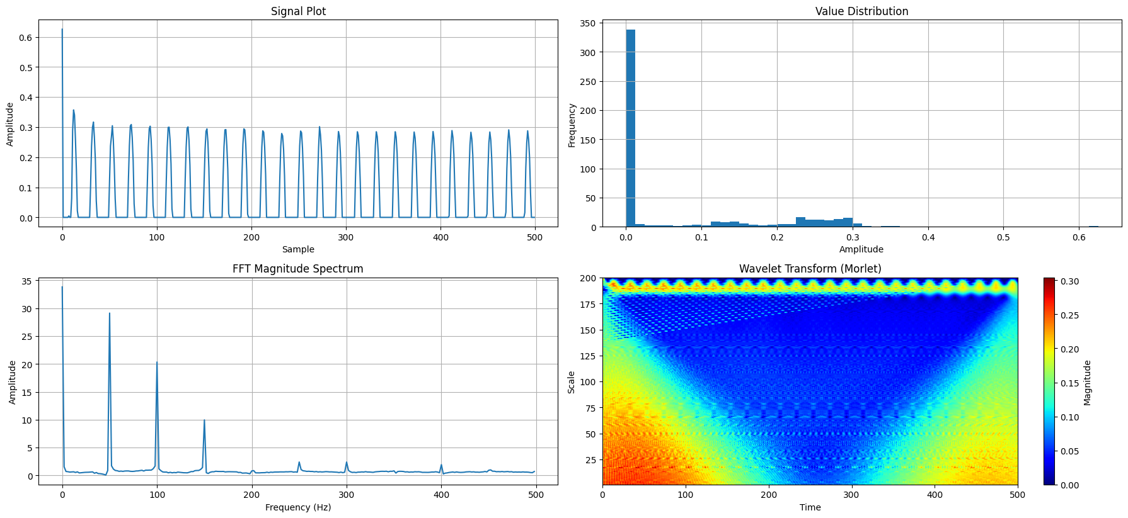

Drop 4:

FFT Max Amplitude: 0.069694

FFT Gradient: 7.864101287741436e-07

Average Time Between Peaks (ms): 1.85

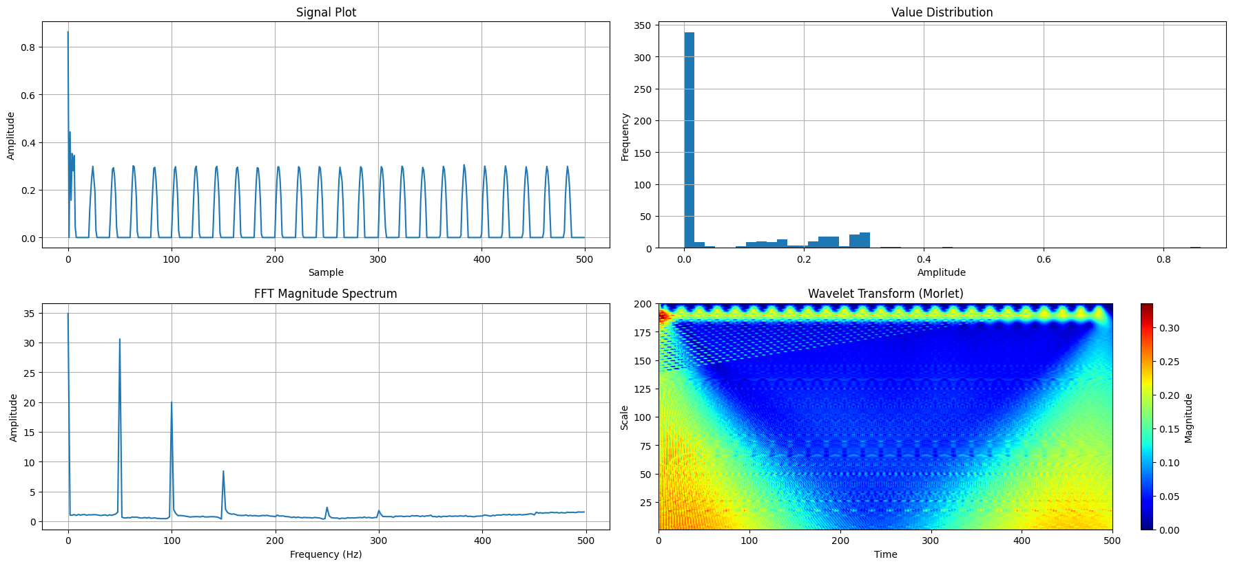

Drop 5:

FFT Max Amplitude: 0.0911426

FFT Gradient: 2.0780944204960667e-06

Average Time Between Peaks (ms): 1.9956521739130435

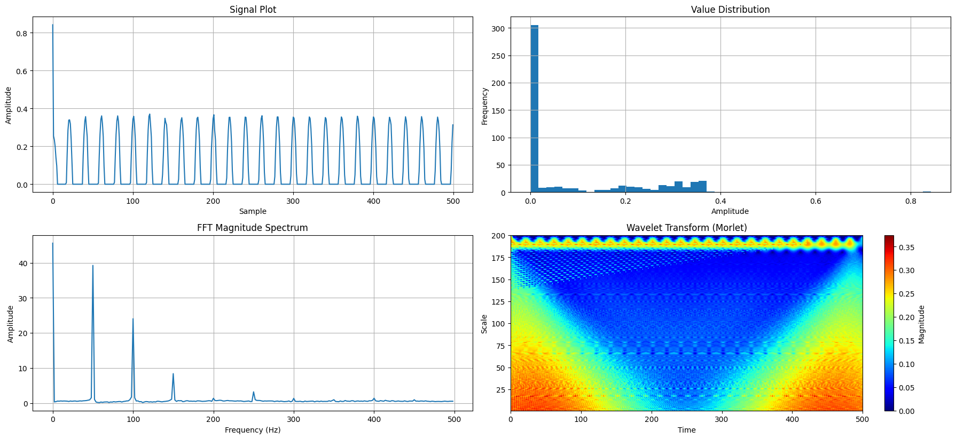

Drop 6:

FFT Max Amplitude: 0.059993000000000005

FFT Gradient: -2.2770821727659523e-07

Average Time Between Peaks (ms): 1.9958333333333333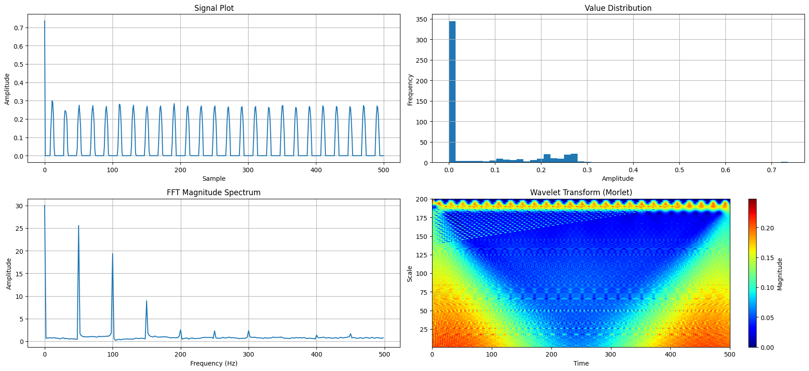

Drop 15:

FFT Max Amplitude: 0.08219820000000001

FFT Gradient: -1.6360560914796449e-06

Average Time Between Peaks (ms): 2.0

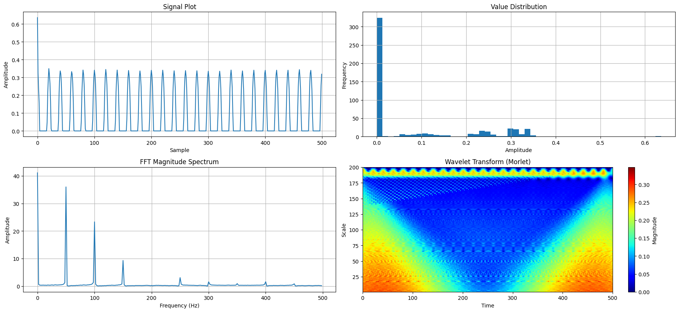

Drop 20:

FFT Max Amplitude: 0.08794559999999998

FFT Gradient: 4.3474876387532585e-06

Average Time Between Peaks (ms): 1.8615384615384616

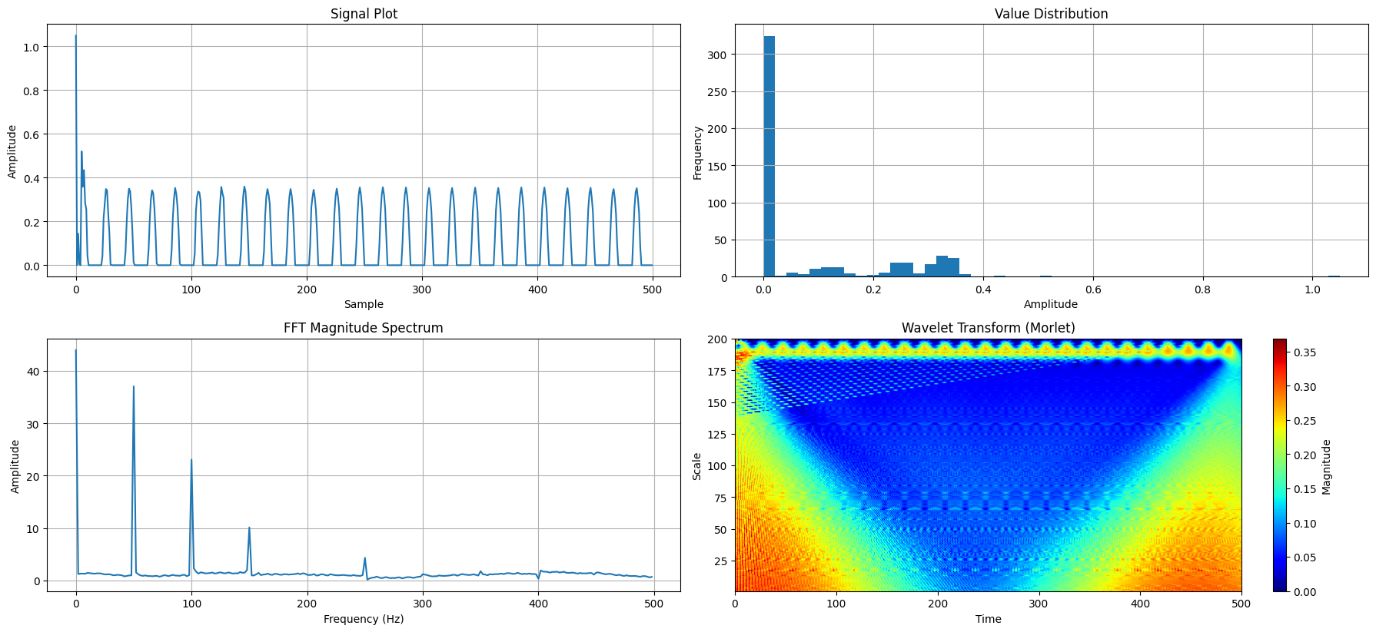

Drop 25:

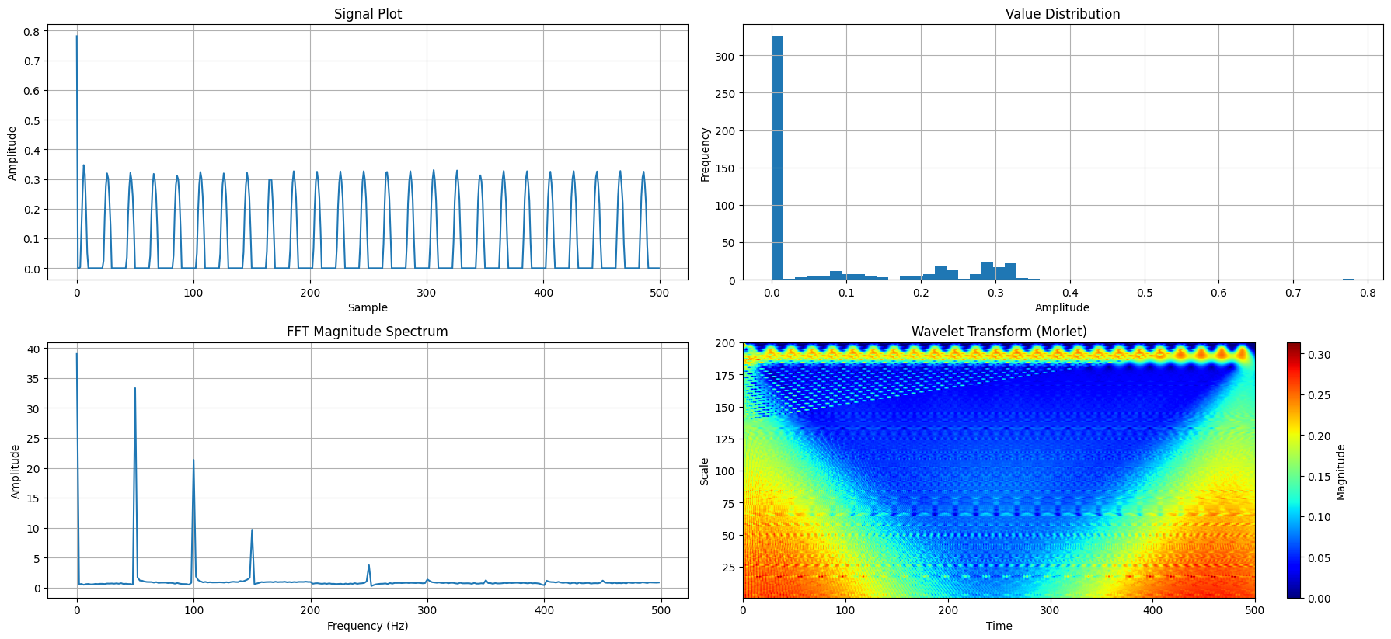

Drop 30:

